1. What is Moore’s Law?  
     
   ________________________________________________________________________  
     
   ________________________________________________________________________  
     
   ________________________________________________________________________  
     
   Does Moore’s law still hold true?  
     
   ________________________________________________________________________  
     
   What effect has Moore’s law had on society?  
     
   ________________________________________________________________________

________________________________________________________________________

________________________________________________________________________

1. You are at a fundraising banquet and sitting on your table two individuals are arguing about computers and the different memory options that exist. Some of the statements that they make are listed below. First, determine which statements are false. Circle the alphabet next to the incorrect statements. Next, fix the incorrect statements in the space provided.
2. **Registers are very large and very fast to access**  
     
   ___________________________________________________________________________
3. **Cache is slow memory that exists on the chip**  
   ___________________________________________________________________________
4. RAM is bigger than cache   
     
   ___________________________________________________________________________
5. RAM is faster to access than data on the hard drive  
     
   ___________________________________________________________________________
6. **Hard drive is on the motherboard and is very slow to access**  
     
   ___________________________________________________________________________
7. Define computational thinking  
     
   _________________________________________________________________________________  
     
   _________________________________________________________________________________  
     
   _________________________________________________________________________________  
   involves solving problems, designing systems, and understanding human behavior, by drawing on the concepts fundamental to computer science.
8. Give an example of an object or effect that it is difficult to represent as a vector-based representation. Give a reason why it is difficult.

_________________________________________________________________________________  
  
_________________________________________________________________________________

_________________________________________________________________________________  
Answer: Anything with a lot of detail will be difficult. Reason: vectors are good at outlining, but when it comes to filling in they are limited. If you try to do detail the vector gets too complex to be useful.

1. Why is it a good idea for a company to have a vector based version of their logo?

_________________________________________________________________________________  
  
_________________________________________________________________________________

_________________________________________________________________________________  
Answer: Certain products require vectors to affix logos to them (t-shirts, hats, vinyl cuts) OR Because sometimes the company will need a lightweight logo for websites and things like that OR It's good to have an image that can scale well, for large billboards and things.

Use the scenario below to answer the next two questions. You ran into a friend from high school while shopping and she mentioned that she was interested in learning how to write computer programs and has decided to learn an assembly language. Your friend has no prior programming experience.

1. What are two reasons why learning an assembly language might be a bad idea?  
     
   _________________________________________________________________________________  
     
   _________________________________________________________________________________

_________________________________________________________________________________

1. Given that your friend has no programming experience, what other type of programming language would be a better choice for your friend to learn.

_________________________________________________________________________________

Use the scenario below to answer the next four questions. As a manager of an exclusive clothing boutique you are tasked with instructing store employees on the best way to arrange store items. The exclusive nature of the boutique and the clientele that you cater too necessitates that the store be optimized for customer comfort. To make time possible, the space in the store for employees to arrange and sort through clothing items is limited. The clothing needs to be arranged by designer (alphabetically) and then by item price (ascending order).

1. In class we discussed a series of sorting algorithms, if the employees were familiar with the simple and insertion sort algorithm, which algorithm would you recommend that they use and why would you recommend that algorithm

_________________________________________________________________________________  
  
_________________________________________________________________________________  
  
_________________________________________________________________________________

________________________________________________________________________________

1. If you were sorting 100 clothing items, on average, how many comparisons are needed using the Selection Sort algorithm discussed in class?  
     
   ____________200_______________________________________________________

1. If you were sorting 100 clothing items, on average, how much space is needed to sort the items when using the Simple Sort algorithm discussed in class?  
     
   ____________200_________________________________________________________
2. One of the other supervisors had previously given the employees instructions (i.e., algorithm) for arranging the items, but the instructions only worked when for shirts, it did not work for skirts. Which computational building block does the algorithm violate?

_________________________________________________________________________________

1. What is unconscious bias?   
   Answer: Unconscious bias is when a person possesses biases but are not aware of them. An example could be offering a job to a man even though they have identical qualifications to a woman.

_________________________________________________________________________________  
  
_________________________________________________________________________________

1. In class we discussed the situation at Facebook involving trending topics, give an example of unconscious bias that may have existed.

_________________________________________________________________________________  
  
_________________________________________________________________________________

____________________________________________________________________________________

1. Explain the difference between unambiguous and ambiguous tasks and give an example of each type of task.

Unambiguous - ____________________________________________________________________________________  
  
____________________________________________________________________________________  
  
____________________________________________________________________________________

Ambiguous - ____________________________________________________________________________________  
  
____________________________________________________________________________________  
  
____________________________________________________________________________________

Answer: Tasks that do not involve classification. Tasks such as sorting numbers or doing mathematical operations do not involve “fairness”. Answer: For unambiguous tasks the input, mode of evaluation, and output are all clear. For ambiguous tasks the input can be variable, the evaluation can be subjective, and the output is sometimes clear but can also be variable.

For the number conversion problems, Write the answer in the space provided. Use the provided extra sheet for your rough work.

1. Convert 0xD0A to binary  
     
   _________________________________________________________________________________
2. Convert 0x10A to decimal  
     
   _________________________________________________________________________________
3. Convert decimal 202 to hexadecimal  
     
   ________________________________________________________________________________
4. Convert decimal 157 to binary  
     
   _________________________________________________________________________________
5. Convert 0b10101111 to decimal  
     
   _________________________________________________________________________________
6. Convert 0b1111000100 to hexadecimal  
     
   _________________________________________________________________________________
7. What image is represented by the following sequence?  
   4,0,2,3,2,1,4,0

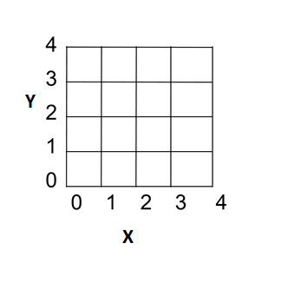

For the following snap programs when asked What does the sprite say when this program is run?, you do not need to indicate the number of seconds the message is displayed on the screen. Just write down the message in the space provided.

1. What does the sprite say when this program is run?

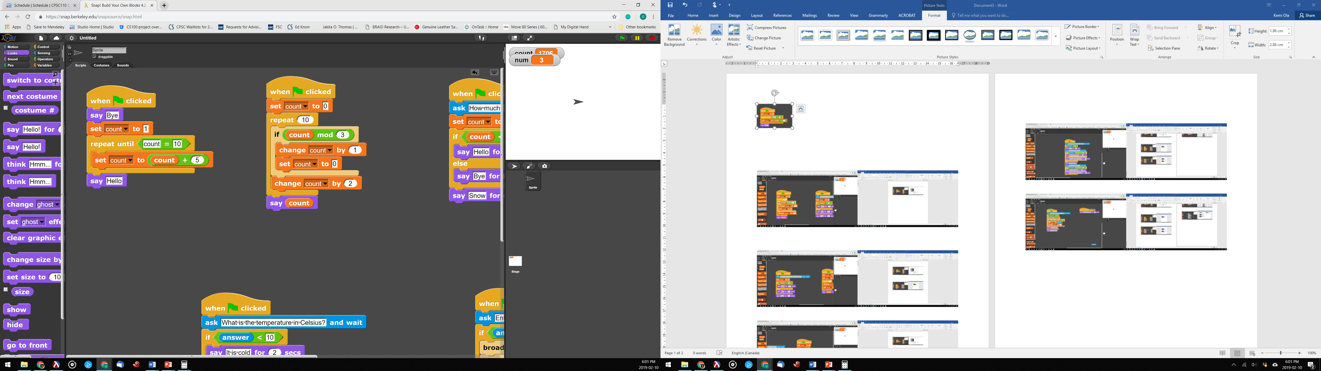

________________________________________  
  
  
________________________________________

________________________________________

1. If the user input is 5, what does the sprite say when this program is run?

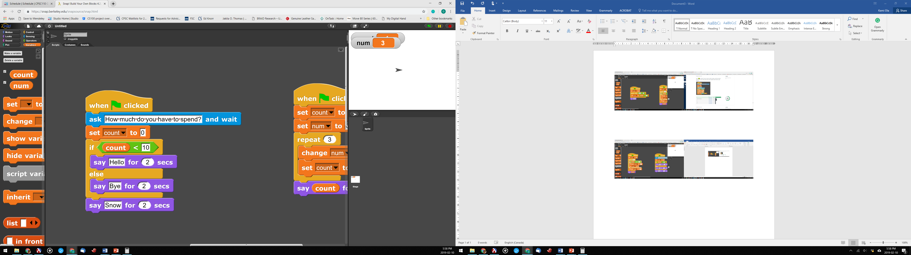

________________________________________  
  
  
________________________________________  
  
  
________________________________________

1. What does the sprite say when this program is run?

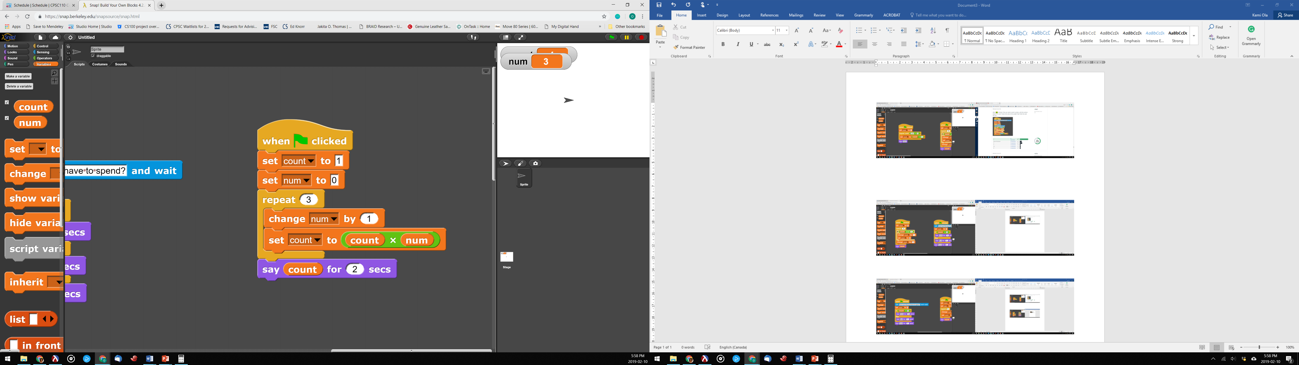

________________________________________  
  
  
________________________________________

________________________________________  
  
  
________________________________________

1. For the given input what does the sprite say when the program is run?   
   Fill in the table for each input

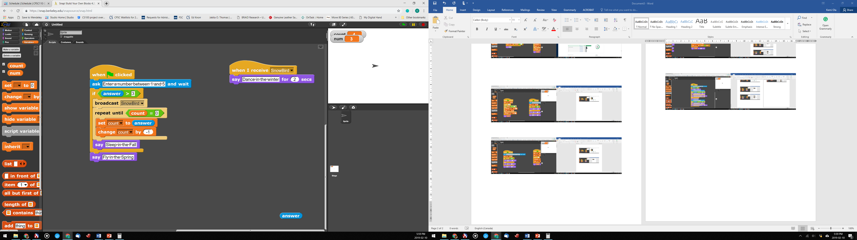

|  |  |
| --- | --- |
| User input | Output |
| 4 | Dance in the winter ______________________________  ______________________________ |
| 2 | Fly in the Spring ______________________________  ______________________________ |

1. For the given input what does the sprite say when the program is run?   
   Fill in the table for each input

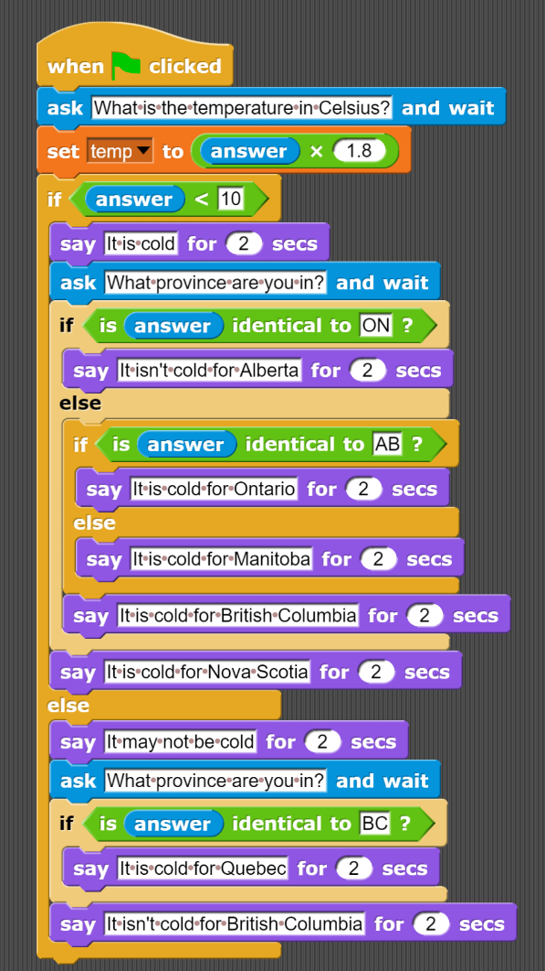

|  |  |  |
| --- | --- | --- |
| What is the temperature in Celsius? | What province are you in? | Output |
| 5 | AB | It is cold It is cold for Ontario It is cold for British Columbia It is cold for Nova Scotia  ______________________________ ______________________________  ______________________________ ______________________________ |
| 15 | BC | It may not be cold It is cold for Querbec It isn’t cold for British Columbia  ______________________________ ______________________________  ______________________________ ______________________________ |

1. As a photographer for the Canadian Broadcasting Company, you constantly find yourself in a position that requires you to take pictures and send them to your boss. Currently you are trying to determine which best compression format to use. If you wanted to preserve the original quality of the image which bitmap compression format should you use and why?

_______________________________________________________________________________________  
  
_______________________________________________________________________________________  
  
_______________________________________________________________________________________

As an employee of an advertising agency, you are tasked with determine developing a classifier that will correctly determining if an ad will be controversial or not. You have data that includes all the past ads for your company. What are the five steps that you need to engage in, in order to create the classifer.   
_______________________________________________________________________________________  
  
_______________________________________________________________________________________  
  
_______________________________________________________________________________________  
  
_______________________________________________________________________________________  
  
_______________________________________________________________________________________  
  
_______________________________________________________________________________________  
  
_______________________________________________________________________________________

1. As a painter you are in the habit of using a color palette that clearly states each color. You are now working on a project that requires you to work with the hex representation of each color. In order to make your work go seamlessly you decided to create a cell phone app that consumes a hex color and produces the color palette equivalent. For instance, if your app is given the hex code #FF00FF, it should produce “a shade of purple”. Create an algorithm that reads in a hex code and produces the color palette shade. Assume that you have a lookup table stored on your phone that details the combination of primary colors. A snippet of the table is shown below

|  |  |  |
| --- | --- | --- |
| Primary Color 1 | Primary Color 2 | Result |
| Red | Blue | Purple |
| Red | Green | Yellow |
| … |  |  |

Note: you are not asked to complete the lookup table. The full lookup table exists on your phone.

_______________________________________________________________________________________  
  
______________________________________________________________________________________  
  
_______________________________________________________________________________________  
  
_______________________________________________________________________________________  
  
_______________________________________________________________________________________  
  
_______________________________________________________________________________________  
  
_______________________________________________________________________________________  
  
_______________________________________________________________________________________  
  
_______________________________________________________________________________________  
  
_______________________________________________________________________________________  
  
_______________________________________________________________________________________  
  
_______________________________________________________________________________________

____________________________________________________________________________________  
  
____________________________________________________________________________________  
  
_________________________________________________________________________________

**Information you may find useful. This sheet will NOT be graded.**

|  |  |
| --- | --- |
| Powers of two | Hexadecimal digits |
| |  |  | | --- | --- | | 2 raised to the power of |  | | 0 | 1 | | 1 | 2 | | 2 | 4 | | 3 | 8 | | 4 | 16 | | 5 | 32 | | 6 | 64 | | 7 | 128 | | 8 | 256 | | 9 | 512 | | |  |  | | --- | --- | | Binary Representation | Hexadecimal representation | | 0000 | 0 | | 0001 | 1 | | 0010 | 2 | | 0011 | 3 | | 0100 | 4 | | 0101 | 5 | | 0110 | 6 | | 0111 | 7 | | 1000 | 8 | | 1001 | 9 | | 1010 | A | | 1011 | B | | 1100 | C | | 1101 | D | | 1110 | E | | 1111 | F | |

**This sheet is left blank for rough work. Nothing on this sheet will be graded.**